**The ICAEFM 2024 Template**

|  |  |
| --- | --- |
| Tập tin:Logo Đại học Mở TPHCM.png – Wikipedia tiếng Việt | Tập tin:Nha Trang University Seal.png – Wikipedia tiếng Việt |

**International Conference Accounting, Economics, Finance, Management 2024: Navigating the Future of Finance, Accounting, and Auditing**

**August 30th, 2024 Ho Chi Minh city, Vietnam**

***[1]***

|  |
| --- |
| **ABSTRACT**  Please provide an abstract of 200 to 300 words  ***Keywords:*** please provide 3 to 5 keywords which can be used for indexing purposes |

1. Main Text

The paper introduction, including any necessary nomenclature, should be enclosed in a box with the same font size as the rest of the paper. The paragraphs should seamlessly flow from the introduction, with divisions only made for headings, subheadings, images, and formulas. Section headings should be numbered, displayed in bold, and set at a font size of 12 pt. Following this section, authors will find additional instructions.

For proper submission of your manuscript, please adhere to the following guidelines. Submit your manuscript in MS Word format using the provided MS Word template for formatting. Embed all figures and tables within the manuscript, avoiding separate submissions. Format your manuscript in Times New Roman font, single-spaced, with 2.5cm margins and a 12-point readable font throughout.

Ensure the length of your paper is under 9000 words, include resentences, Appendix. To avoid processing issues, use normal fonts and avoid special fonts, especially those used in Far Eastern languages. Utilize the 'spellchecker' function in MS Word for error prevention.

When structuring your manuscript, follow this sequence: Title, Authors, Affiliations, Abstract, Keywords, Main Text (including figures and tables), Acknowledgements, References, Appendix. Place acknowledgements in a separate section at the end, avoiding inclusion on the title page or as footnotes. If using bulleted lists, follow the provided format. Please refrain from modifying the formatting and style layouts of the template document. Prepare your manuscript in a one-column format suitable for direct printing on paper with a trim size of 210 x 297 mm. Omit page numbers on the front, as they will be added separately. Maintain clear paragraph spacing throughout.

**Section headings**

To ensure proper formatting of section and subsection headings, please follow these guidelines: Left justify the section headings and apply bold formatting to them. Capitalize the first letter of each word in the section heading and number them consecutively, starting with "1. Introduction." Leave a minimum of three text lines after each section heading before introducing a page or column break. For subsection headings, use capital and lower-case italic letters, number them as "1.1, 1.2, etc.," left justify them, and indent the second and subsequent lines. Ensure a minimum of three text lines follow each subsection heading before introducing a page or column break. Remember to avoid leaving the text area blank, except for the last page, and ensure that the content fills the page appropriately.

* 1. **Tables**

Tables in your manuscript should be numbered with Arabic numerals and have a caption. The figure number and caption should be centered and typed below the illustration using a 12 pt font. Headings for tables should be left justified and placed above the tables. Within the tables, use horizontal lines only to distinguish column headings from the table body, and include a horizontal line immediately above and below the table. Remember to embed the tables within the text and not provide them separately. Here's an example format that authors may find useful.

**Table 1.** An example of a table.

|  |  |  |
| --- | --- | --- |
| **An example of a column heading** | **Column A** | **Column B** |
| And an entry | 1 | 4 |
| And another entry | 2 | 5 |
| And another entry | 3 | 6 |

* 1. **Figures**

Figures in your manuscript should be numbered using Arabic numerals (e.g., 1, 2, 3, etc.) and accompanied by a caption. The figure number and caption should be centered below the illustration, using a 12pt font. However, if two images can be placed side by side without compromising clarity, they may be presented together to save space. In such cases, refer to them as "Fig. 1" (or the appropriate figure number) for clarity. Please note that all photographs, schemas, graphs, and diagrams should be referred to as "figures." Line drawings should be of high quality scans or true electronic output. Ensure adherence to these guidelines for consistent formatting and presentation of figures in your manuscript.

(a) (b)

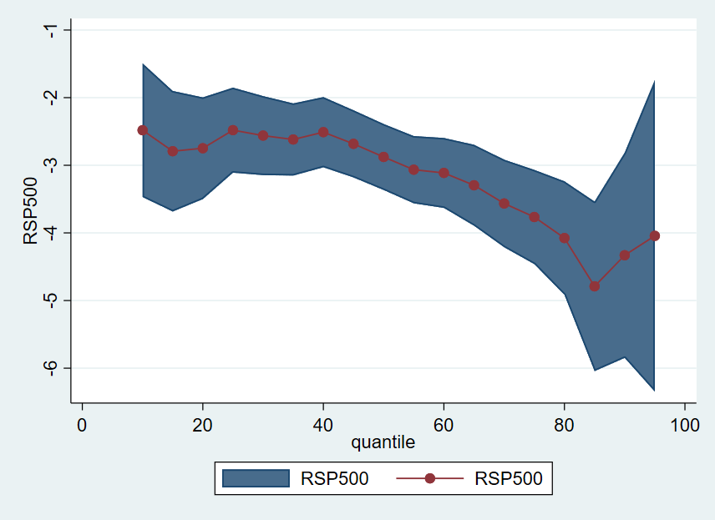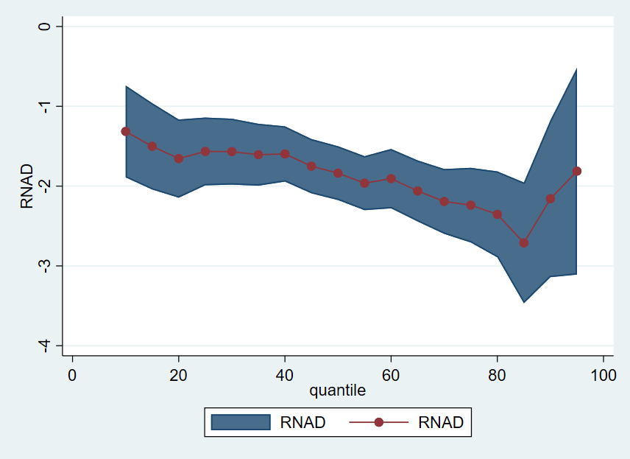

**Fig. 1.** (a) first picture; (b) second picture.

* 1. **Equations**

Equations and formulae in your manuscript should be typed using Mathtype. Number them consecutively with Arabic numerals, enclosed in parentheses, and aligned to the right-hand side of the page. Place equation numbers only if they are explicitly referred to in the text. Additionally, equations and formulae should be separated from the surrounding text by a single space. Adhering to these guidelines will ensure clear and consistent presentation of Description: http://voer.edu.vn/file/32111equations and formulae in your manuscript.

(1)

* 1. **Footnotes**

If possible, it is recommended to minimize the use of footnotes. However, if necessary, please adhere to the following guidelines: Number footnotes consecutively throughout the article using Arabic numerals (e.g., 1, 2, 3, etc.)[2]. Format the footnotes with a smaller font size (8 pt) and single spacing. Place the footnotes at the bottom of the page in which they are referenced, separated from the main text by a single line space extending at the foot of the column. It is important to avoid changing the margins of the template to ensure that footnotes remain within the printing range. By following these guidelines, you can effectively incorporate footnotes into your manuscript while maintaining a consistent and readable format.

* 1. **Construction of references**

Please ensure that every reference cited in the text is also present in the reference list (and vice versa). Any references cited in the abstract must be given in full. References must be listed at the end of the paper. Do not begin them on a new page unless this is absolutely necessary. Authors should ensure that every reference in the text appears in the list of references and vice versa. Indicates references by [1] and [2,3] in the text. Some examples of how your references should be listed are as follows: (APA style)

**Book:**

Inkson, K., & Kolb, D. (2002). *Management: Perspectives for New Zealand*. Prentice Hall.

Baltagi, B. H., & Baltagi, B. H. (2008). *Econometric analysis of panel data* (Vol. 4). Chichester: Wiley.

**Journals:**

Abuzayed, B., Bouri, E., Al-Fayoumi, N., & Jalkh, N. (2021). Systemic risk spillover across global and country stock markets during the COVID-19 pandemic. *Economic Analysis and Policy*, *71*, 180-197.

* 1. **File naming and delivery**

When submitting your manuscript to the system, please title your files in the following order: “**ICAAFM2023_first author’s name**”.

Acknowledgements

The headings for "Acknowledgements" and "References" should be left justified, bold, with the first letter capitalized, but without any numbering. The text below these headings should continue in a normal manner.

Appendix

If authors include an appendix section, it should be placed before the References section. Multiple appendices should follow the same heading style as shown above, automatically ordered as A, B, C, etc.

For example, Appendix A.1 demonstrates a sub-heading within an appendix. You also have the option to include subheadings within the appendix if desired.

1. * Corresponding author. Tel.: +84 (phone number).

   E-mail address: [abc@ou.edu.vn](mailto:abc@ou.edu.vn)
2. Footnote text